

**Module Code & Module Title**

**CS6P05NI Final Year Project**

**Assessment Weightage & Type**

**5% FYP Proposal**

**Year and Semester**

**2024-25 Autumn**

**Smart Banking System**

**Student Name: Nischhal Shrestha**

**Group: AI3**

**London Met ID: 22085857**

**College ID: np01ai4s230009@islingtoncollege.edu.np**

**Assignment Due Date: 4th December 2024**

**Assignment Submission Date: 4th December 2024**

**Submitted To:**

**External Supervisor- Shristi Shakya**

**Internal Supervisor- Roshan Shrestha**

**Word Count :3400**

*“I solemnly confirm that I hereby understand that my coursework needs to be submitted online through Turnitin portal under the relevant module FYP before the deadline for my coursework to be accepted and marked. I am fully aware that late submissions will be treated as non-submission and a marks of zero will be awarded.”*



**Acknowledgement**

I would like to express my heartfelt gratitude to my university, Islington College, my supervisors and my friends for contributing to the successful completion of the Smart Banking System project.

Firstly, I would like to extend my sincere thanks to my college and the department of FYP department for providing me with the opportunity to work on this innovative project. Their support, resources, and encouragement played a significant role in bringing this idea to life.

I am deeply indebted to my project supervisors Shristi Shakya and Roshan Shrestha, for guiding me with their expertise and constructive feedback. They were invaluable throughout the development process of my project. Their insights greatly enhanced the scope and quality of this project.

I also acknowledge the contributions of my teachers and AI enthusiast friend, whose creative ideas enriched the project’s development. Their shared knowledge and dedication were instrumental in achieving our goals.

Finally, I’d like to express my gratitude to my family and friends for their constant motivation, support and understanding, they helped me with the moral support necessary to overcome challenges during the course of this project.

**Abstract**

The Smart Banking System integrates artificial intelligence (AI) and advanced security mechanisms to modernize banking operations. This web-based application features a user-friendly chatbot capable of addressing banking queries, facilitating fund transfers, and offering tailored financial advice. The system incorporates fraud detection algorithms to analyze transactions, promptly notifying users of potential fraudulent activities. By automating repetitive tasks such as FAQs and interest calculations, it significantly reduces operational costs while enhancing customer satisfaction. Built with a strong emphasis on data privacy, compliance, and usability, this project is designed to join the gap between traditional banking and modern digital solutions. The system demonstrates a practical approach to improving customer experience while addressing pressing concerns such as cybersecurity risks in the financial sector.

Table of Contents

1. Introduction: 1

1.1 Problem Statement 2

1.2 The project as a solution 2

2. Aims and Objectives: 4

2.1 Aim 4

2.2 Objective 4

3. Expected Outcomes and Deliverables: 5

4. Project risks, threats and contingency plans: 5

6. Resource Requirements : 9

6.1 Hardware Requirements: 9

6.2 Software Requirements: 9

7. Work breakdown structure: 11

8. Milestones: 12

9. Project Gantt chart 14

10. Conclusion 17

11. Bibliography & References: 18

12. Appendix 19

1. Similar Projects 19

2. Use Cases 20

3. System Flow Chart 21

4. Future Development Plan: 22

5. Targeted Audiences: 22

6. Considered Methodology: 23

**Table of Figures**

Figure 1 Potential Use cases of Banking chatbots 1

Figure 2 Competition to implement chatbots in Financing Sector 3

Figure 3 Scrum Framework (Bala, 2024) 8

Figure 4 WBS 11

Figure 5 Gantt Chart feasibility & planning 14

Figure 6 Gantt Chart Development I 14

Figure 7 Gantt Chart Development II & Deployment 15

Figure 8 Gantt Chart Summary 16

Figure 9 Use Case Diagram 20

Figure 10 Flowchart of the system 21

Figure 11 KanBan Board 23

Figure 12 Prototype Methodology 24

Figure 13 Spiral Methodology 25

Figure 14 Waterfall Methodology 26

Figure 15 Extreme Programming Methodology 27

Figure 16 Lean Development Methodology 27

Figure 17 Feature Driven Development 28

**Table of Tables**

Table 1 Other similar projects 19

**FYP proposal**

**Smart Banking System**

*(with AI enforced chatbot & fraudulent transaction detection)*

# Introduction:

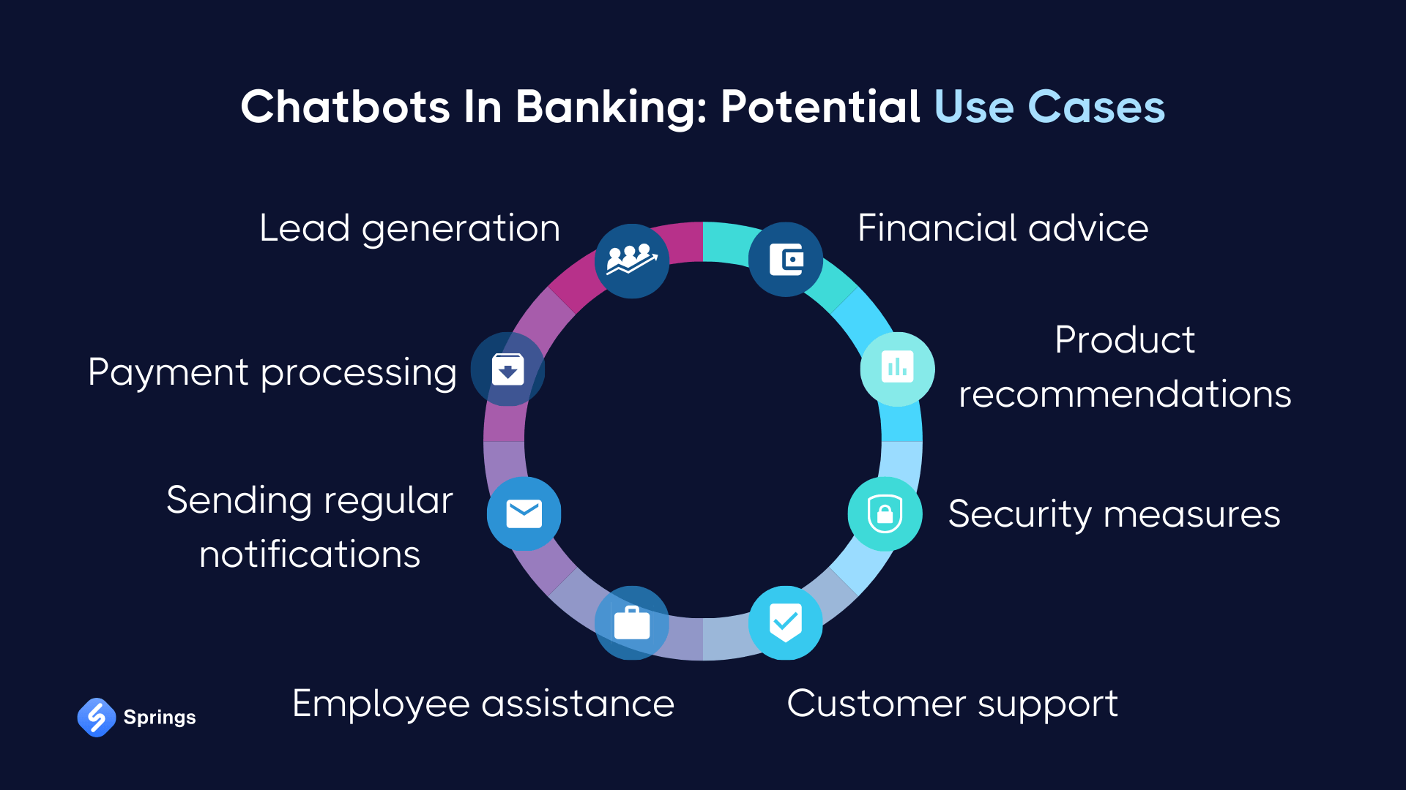A banking management system is a web based application designed for simplifying heavy tasks of banking stakeholders. In addition to conventional banking system, smart banking allows users to query on any bank related questions like creating an account, loan, credit cards, insurance , investment plant, interest rate, etc. through a AI chat model from the comfort of their home. Smart Banking will also be able to notify users in cases of fraudulent transactions.

(Serhii, 2024)

Figure 1 Potential Use cases of Banking chatbots

## 1.1 Problem Statement

1. The Cyber Bureau of Nepal Police (CBNP) reported 4646 cases of cybercrimes involving fake identities, password hacking, OTP manipulation, and other fraudulent activities last fiscal year. (Sarahna, 2024). With alarming advancement of technology comes the challenge of cyber security threats. The challenges intensify as there are no proper cyber laws in Nepal to address the threats that cybercrime possess.
2. In today's fast-paced world, the financial industry must keep up with the demand for quick and efficient information processing to serve customers better. With clients expecting seamless experiences and the integration of banking with IT, telecommunications, and retail, banks face increased risks of cyber-attacks and fraud. This not only affects their revenue but also erodes customer trust. As customer numbers grow, bank employees struggle to meet their needs, often answering repetitive questions, which adds to their stress.

## The project as a solution

Adapting to new technologies, such as AI-enabled chatbots, can help banks provide faster, more secure, and efficient customer service, addressing the need for quick information access. This chatbot would also be able to :

* Assist with essential Banking Activities:
* Answer FAQs
* Provide proactive support
* Help customers apply for facilities provided by banks
  1. **Unique Selling Point**
  2. Smart Banking is a user friendly web based UI providing ease and simplicity to its customers. Smart Banking is essential to both end users. The chatbot's advanced security features help mitigate the risks of cyber-attacks and fraud, protecting both the bank's revenue and customer trust in an environment lacking robust cyber laws. This dual focus on security and efficiency makes our chatbot an indispensable tool for modern banking. Financing firms are slowly changing their operations nature and the way they interact with customers as advancement in A.I. Banks and every financial must equip their system software with chatbot to stay in competition. (Praveen, 2024)

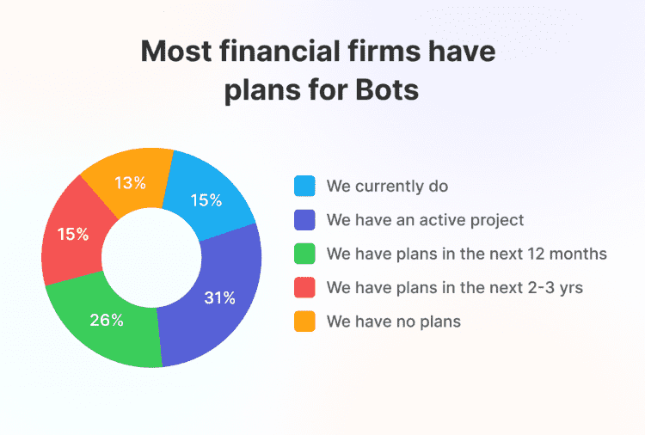

Figure 2 Competition to implement chatbots in Financing Sector

# Aims and Objectives:

## 2.1 Aim

The aim is to facilitate users with secure transactions notifying with alerts in potential fraudulent transactions, and assist them in banking operations at immediate level with the help of smart chatbot.

## 2.2 Objective

The objective of this project are as follows:

1. To develop a full bank management system.
2. To store the data on backend.
3. To develop a platform where the customers can sign-in by using credentials provided by bank.
4. To develop an interface where the users can perform transactions online or cash withdrawal.
5. To perform fraud detection on transactions and alert users in case of any anomalies.
6. To train the chatbot on FAQs “to the point answering” of user’s questions using python.
7. To perform difficult tasks such as interest calculation and installment prediction on loans.
8. To provide cost cutting mechanism for banks by automating repetitive tasks and improving customer satisfaction availing banking service.
9. To utilize AI tools to offer recommendations like loan offers, foreign currency exchange rate.
10. To enable users for seamless and secure fund transfer, bill payments, and account updates.

# Expected Outcomes and Deliverables:

1. A user-friendly web based application which facilitates efficient and convenient use of banking queries streamlining banking procedure.
2. This project employs fraud detection analysis technique on its every transactions notifying the customers of fraudulent transactions if any strengthening security.
3. The smart bot simplifies complex banking procedures including fund transfer, bill payments, loan processing and more.
4. A 24/7 customer support mechanism that eliminates wait time for basic banking queries like checking account balance, statement summary and more.
5. Smart Banking Bot reduces the operational cost by automating repetitive tasks.

# Project risks, threats and contingency plans:

When developing an AI-powered banking chatbot, there are several potential risks that could arise, and having a backup plan in place is crucial to address these issues effectively. Here’s a breakdown of possible risks and the contingency plans for each:

**4.1 Data Privacy and Security Risks**

**Risk:** Chatbots will handle sensitive customer information (e.g., account details, personal identification). A breach could lead to data theft, financial losses, and loss of customer trust.

**Contingency Plan:**

* Implement End-to-End Encryption: Encrypt all customer interactions and sensitive data.
* Compliance with Regulations: Perform frequent security checks like internal audit and penetration testing to identify vulnerabilities.
* Anonymization and Access Control: Anonymize sensitive data and implement strict access controls to prevent unauthorized access.

**4.2. Inaccurate Responses or Miscommunication**

Risk: The chatbot may misunderstand user queries or provide inaccurate information, potentially leading to customer frustration or financial errors.

Contingency Plan:

* Continuous Model Training: Continuously train the chatbot using real customer interactions to improve its understanding of diverse queries.
* Fallback Mechanisms: Implement fallback mechanisms to transfer complex or ambiguous queries to a human support agent.
* Feedback Loop: Create a feedback loop where customers can rate the chatbot’s responses, providing data for ongoing improvement.

**4.3. Technical Failures or Downtime**

**Risk:** The chatbot service could experience technical issues, leading to downtime and unavailability, negatively impacting customer service.

**Contingency Plan:**

Redundant Systems: Set up redundant servers and a load balancer to ensure high availability and reduce the risk of downtime.

Automated Monitoring: Equip with real-time monitoring tools & techniques to detect and alert primary users on system failures.

**Disaster Recovery Plan:** Develop a backup plan to restore services quickly in case of a significant failure.

**4.4. Customer Frustration with Limited Functionality**

**Risk**: If the chatbot fails to handle a broad range of queries effectively, customers may become frustrated and lose trust in the system.

**Contingency Plan:**

* Gradual Rollout: Start with basic functionality and gradually expand features as the chatbot learns from interactions.
* Human-in-the-Loop: Allow for seamless transfer to human agents for queries that the chatbot cannot handle.
* Regular Updates: Schedule regular updates and improvements based on customer feedback and interaction data.

**4.5. Overfitting and Bias in AI Models**

**Risk:** The AI model might be biased if trained on a limited dataset, potentially leading to unfair treatment or inaccuracies in responses.

**Contingency Plan:**

* Diverse Training Data: Use diverse datasets to train the chatbot to minimize bias and ensure fairness in responses.
* Regular Model Evaluation: Continuously evaluate the model for bias and retrain with updated data if necessary.
* Human Review: Involve human reviewers to regularly assess the chatbot's interactions for potential bias or inappropriate responses.

**4.6. Integration Issues with Existing Systems**

**Risk:** Integrating the chatbot with existing banking systems (e.g., CRM, databases) could lead to compatibility or security issues.

**Contingency Plan:**

* API and Security Standards: Use secure, standardized APIs for integration and conduct thorough testing to ensure compatibility.
* Staged Integration: Integrate the chatbot in multiple steps, starting with non-critical systems to ensure stability before full deployment.
* Collaboration with IT Team: Work closely with the bank’s IT team to ensure seamless integration and address technical concerns early on.

**4.7. Regulatory and Compliance Challenges**

**Risk:** Failure to comply with banking regulations or data protection laws could result in legal repercussions and financial penalties.

**Contingency Plan:**

* Regular Compliance Checks: Collaborate with legal and compliance teams to ensure the chatbot adheres to current regulations.
* Compliance Audit Trail: Implement an audit trail for chatbot interactions to demonstrate compliance with regulations during audits.
* Customer Consent: Implement mechanisms to obtain customer consent for data usage and handling, and provide easy options for opting out.

1. **Methodology:**

**5.1 Implemented Methodology**

Agile method will be followed throughout this project. Scrum methodology is an agile method for dynamic and iterative approach to software development that prioritizes flexibility, collaboration, and customer-centricity.

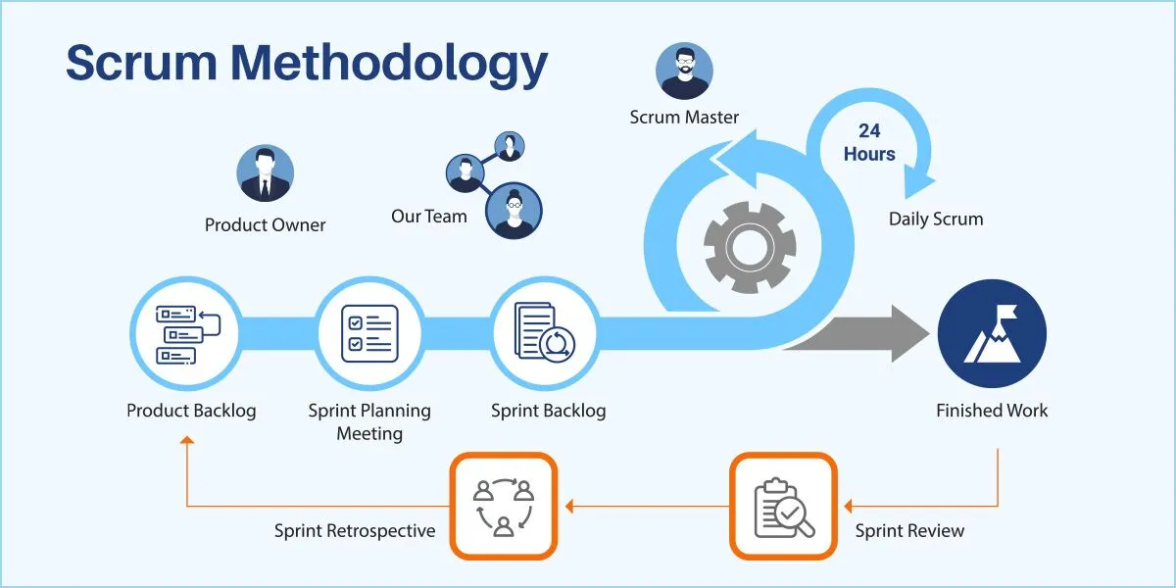

Figure 3 Scrum Framework (Bala, 2024)

**Sprint Planning:** It involves planning short development sprints focusing on specific features, like integrating the banking bot's conversational AI or developing the initial fraud detection model.

**Weekly Standups:** Keeping fellow AI enthusiast, including AI developers, compliance specialists, and business analysts, aligned and aware of progress. (This phase will be replaced by Weekly FYP classes to discuss the progress of the project)

**Review and Retrospectives:** After each sprint, review the progress made on the AI functionalities and fraud detection mechanisms to identify successes, issues, and areas for improvement.

Note: Even if this is a individual based project , agile methodology is slightly modified to meet the project requirements.

**5.2 Considered Methodology**

1. Kanban
2. Prototype
3. Spiral

**5.3 Other methodology:**

1. Waterfall Model
2. Extreme Programming (XP):
3. Iterative Waterfall

# Resource Requirements :

For successful completion of this project required tools and technologies are estimated as follows:

## 6.1 Hardware Requirements:

* **Processor:** Mac OS, Windows or Linux.
* **RAM:** Minimum of 16 GB.
* **GPU:** Dedicated NVIDIA CUDAs
* **Storage:** At least 512 GB SSD for fast data access and storage of models and datasets.

## 6.2 Software Requirements:

1. Operating System: MacOs, Windows 10 or higher
2. IDE: Visual Studio Code
3. Programming Languages:

Python, Next js , SQL, Bash/CLI

1. Frontend Framework:

* React: For building the user interface of the web application

1. Backend Framework:

* django: For backend API development to handle requests and database interaction may be used.
* Appwrite: An API for backend handling and data base interaction might be used for authentication and server side rendering.
* Plaid: An API for our web based system might be used to connect banks.
* Dwolla Environment: An API to send and receive payment specializing actual money transfer might be used .

1. Version Control:

* Git: For version control and managing project changes.
* GitHub: For remote repository hosting and collaboration.

1. Cloud Platforms:

* Google Collab Pro: For cloud-based GPU access and model training.

1. Libraries for Machine Learning and Data Analysis:

* TensorFlow/Keras
* PyTorch
* Pandas
* NumPy
* Matplotlib & Seaborn

1. Scikit-learnWeb Scraping (if required): BeautifulSoup. Selenium
2. Design and Prototyping Tools: Figma
3. Documentation and Flowchart Tools: Draw.io, Gantt Chart

# Work breakdown structure:

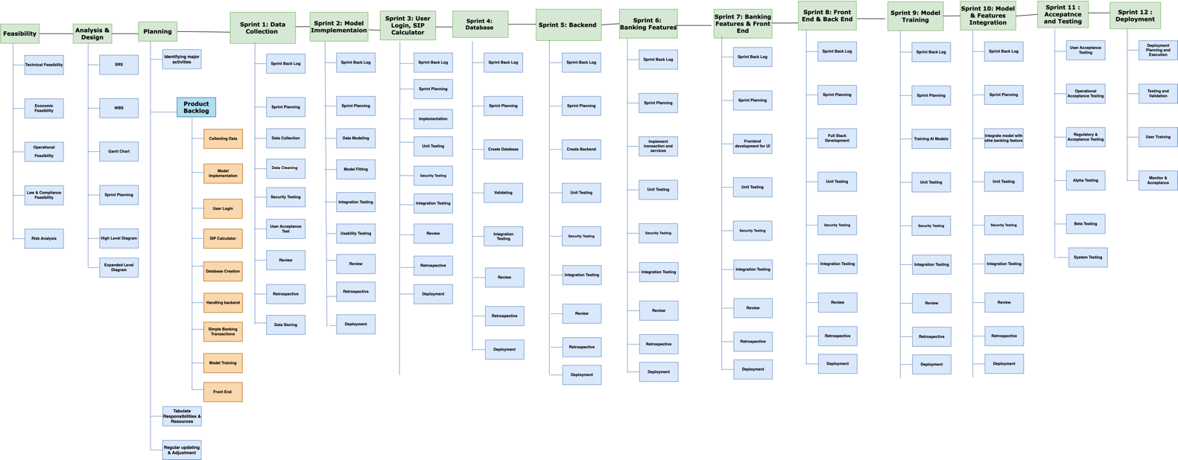WBS, Work Breakdown Structure, is a popular model used across many project management branches. The WBS enables developers to plan, manage, and deliver software projects effectively while promoting collaboration, agility, and risk management. Embracing WBS empowers software engineers to take control of their projects, streamline processes, and drive successful software development. (Baabdullah, 2024). WBS function by breaking complex projects down into smaller chunks so the project become easier to manage.

Figure 4 WBS

# Milestones:

**Milestone 1 Finalize the project:**

After presenting multiple ideas and doing research and discussion with group supervisors (internal and external ) , the project topic was finalized “Integrated Banking System”.

**Milestone 2 Proposal Submission:**

The project is built around the proposal. Proposal involves all the possible

requirements of the project and research required for future developments.

**Milestone 3 System Analysis:**

This milestone contains SRS documents, ERD, and UML diagrams. These all

showcase the requirements and functionalities of the project.

**Milestone 4 Designing:**

Designing is the blueprint of the project. These milestones will contain all the

wireframes and design documents. Creation of these would help in

developing user-friendly UI.

**Milestone 5 Interim Report:**

Interim report plays a vital role in completion of the project as it explains all the project features and functionality in complete detail through different diagrams.

**Milestone 6 Login System:**

This milestone is dedicated to developing a fully-fledged login system for the project

using user authentication.

**Milestone 7 Banking ChatBot:**

This milestone is based on developing and training a chat bot where users can see the chat with the smart bot and post queries related to banking.

**Milestone 8 Transactions:**

This milestone allows users to perform day to day banking transactions such as deposit or withdraw cash, require bank statement, balance inquiry, etc

**Milestone 9 Database Creation**

Developing and integrating database where users data is stored and their day to day transactions are recorded.

**Milestone 10 Customer Search System:**

Developing a search feature to allow bank staffs to search customers information with a registered bank account.

**Milestone 11 Documentation:**

Documenting the project with an exceptional report that excellently documents every process involved while developing the project including documentation of testing and validations.

**Milestone 12 Deployment:**

After thorough testing and being satisfied with the project the project is deployed for public use.

# Project Gantt chart

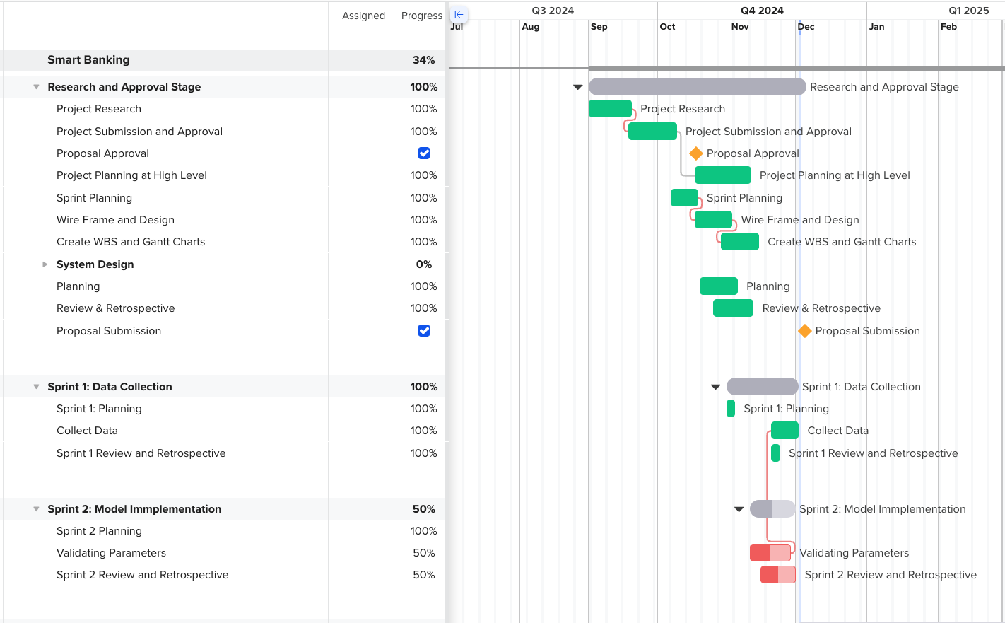

Figure 5 Gantt Chart feasibility & planning

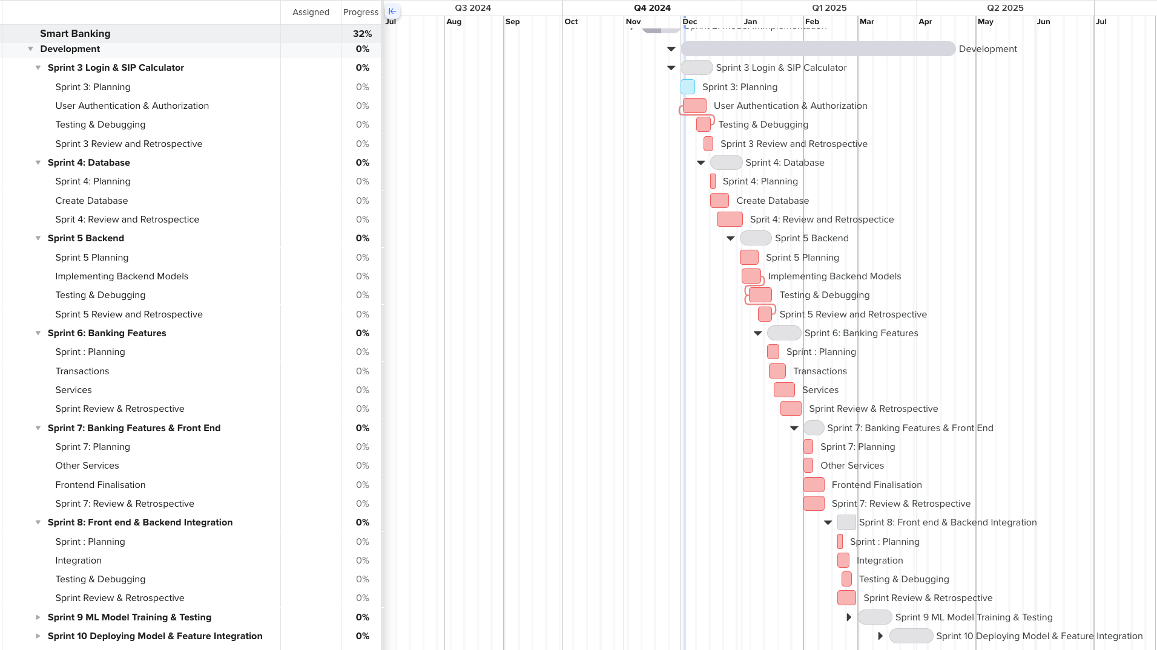Figure 6 Gantt Chart Development I

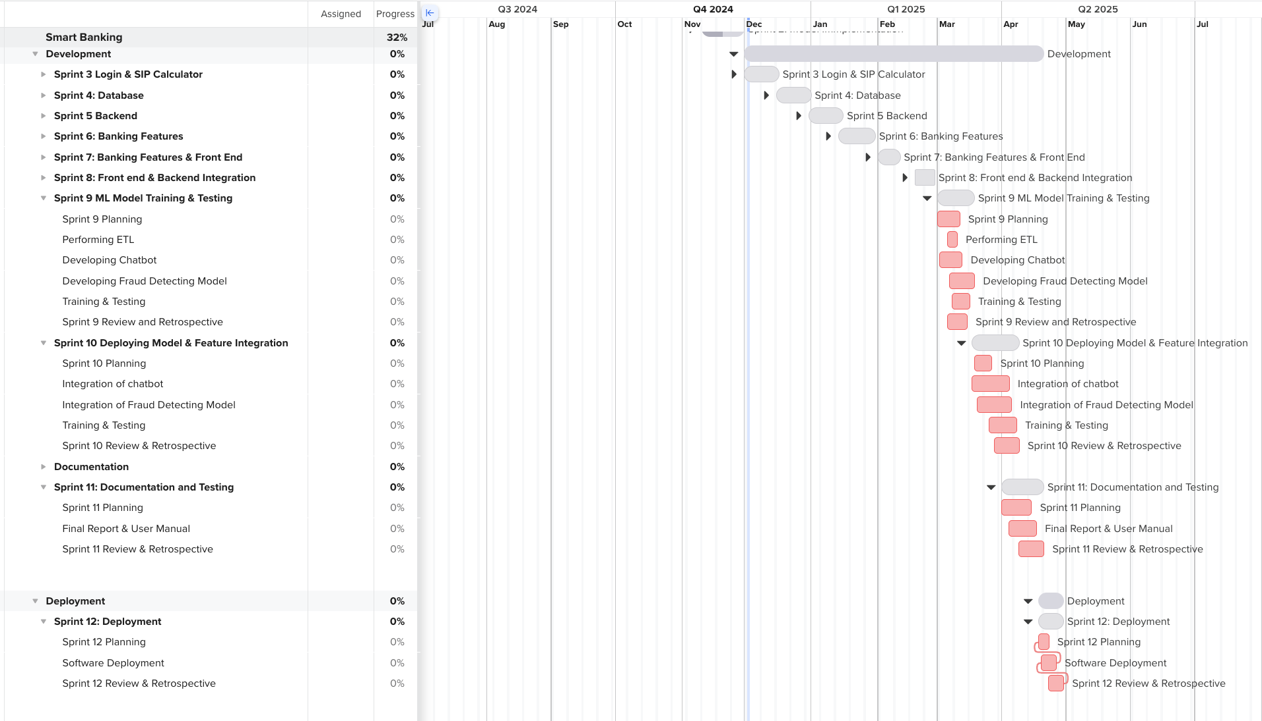

Figure 7 Gantt Chart Development II & Deployment

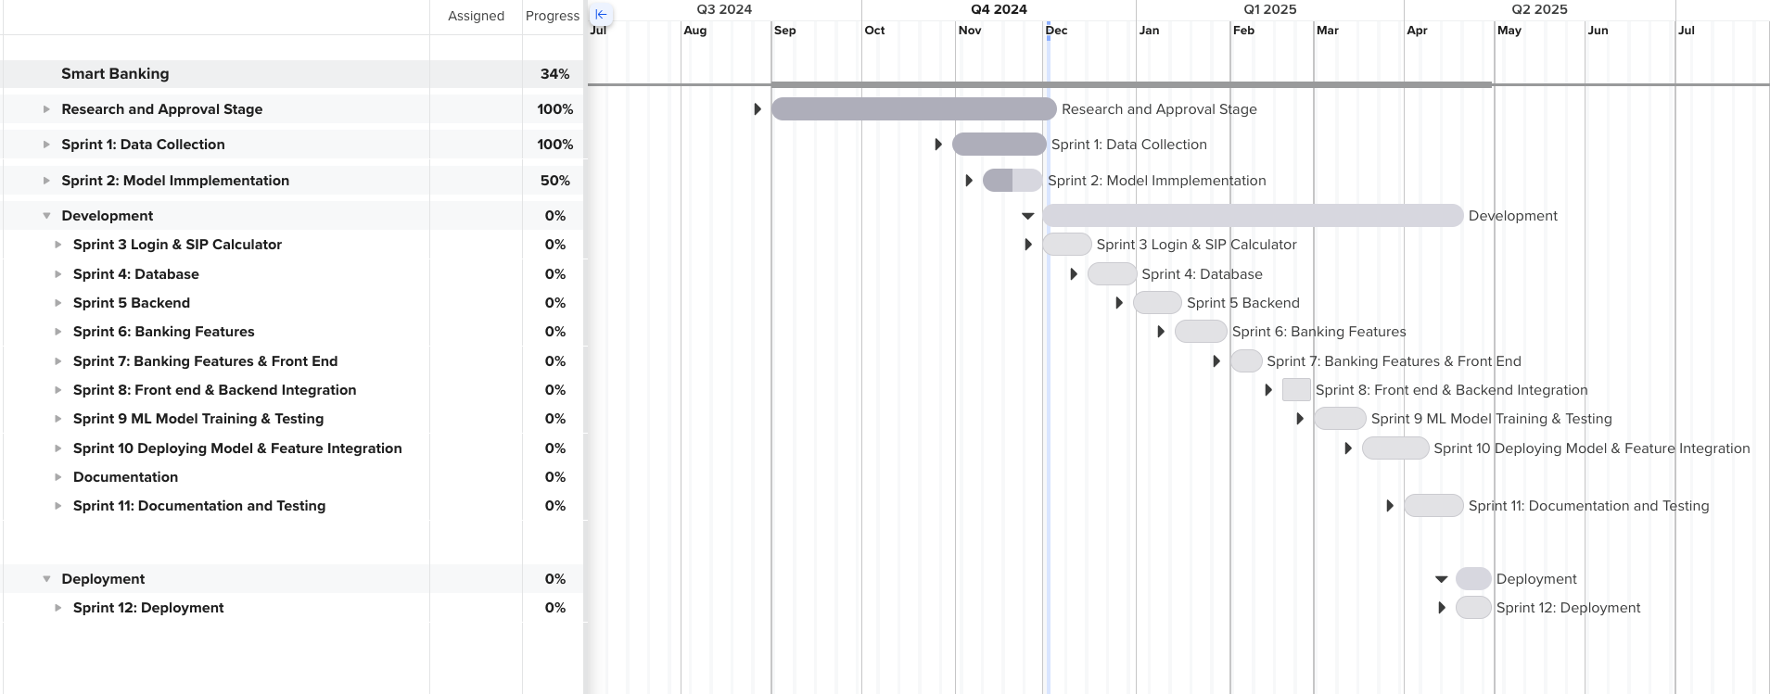

Figure 8 Gantt Chart Summary

# Conclusion

The Smart Banking System is a user-friendly system with a step forward in the evolution of banking services. It employes cutting-edge AI capabilities with robust fraud detection user-friendly design. By automating customer interactions and simplifying complex banking procedures, the system enhances operational efficiency and customer satisfaction. Its fraud detection mechanism strengthens the security of financial transactions, instilling confidence in users. Moreover, the integration of secure authentication and compliance measures ensures the system meets modern cybersecurity standards. As financial institutions face increasing competition and customer demands, this project showcases a scalable and innovative solution that addresses these challenges, setting a foundation for the future of smart banking.

# 11. Bibliography & References:

Baabdullah, H. (2024, 05 05). *LinkedIn*. Retrieved from LinkedIn: https://www.linkedin.com/pulse/enhancing-software-engineering-work-breakdown-project-baabdullah-j7vkf

Bala. (2024, 05 04). *Software Development*. Retrieved from Zaigo Infotech: https://www.zaigoinfotech.com/what-is-scrum-methodology/

Chirag. (2021, 06 22). *Analytics Vidhya*. Retrieved from Vectorization in NLP: https://www.analyticsvidhya.com/blog/2021/06/part-5-step-by-step-guide-to-master-nlp-text-vectorization-approaches/

KissFlow. (2023, 11 16). *Agile*. Retrieved from Kissflow: https://kissflow.com/project/agile/kanban-methodology/

Neural, N. (2023, 07 23). *Label Encoding: Naming the Unnamed Categories*. Retrieved from Let's Data Science: https://letsdatascience.com/label-encoding/

Parag, M. (2024, 08 05). *Software Development*. Retrieved from Positiwise: https://positiwise.com/blog/what-is-software-development-methodology

Praveen, S. (2024, July 15). *Chatbots for Financial Services: Benefits, Examples, and Trends*. Retrieved from Revechat: https://www.revechat.com/blog/chatbots-for-financial-services/

Sarahna, K. (2024, February 11). *The Kathmandu Post*. Retrieved from The Kathmandu Post: https://kathmandupost.com/money/2024/02/11/as-online-shopping-takes-off-cases-of-fraud-tick-up

Serhii, U. (2024, September 19). *The 2024 Guide To Chatbots In Banking*. Retrieved from Springs: https://www.springsapps.com/knowledge/the-2024-guide-to-chatbots-in-banking#chatbots-in-banking-real-examples

Yuriy, R. (2019, 04 23). *Software Development Methodologies*. Retrieved from CodeIt: https://codeit.us/blog/software-development-methodologies

# 12. Appendix

## 1. Similar Projects

Table 1 Other similar projects

|  |  |  |  |
| --- | --- | --- | --- |
| Project Name | Main Findings/Result | Methodology Used | Project Contribution |
| Erica (Bank of America) | The chatbot assists with notifications, balance inquiries, and financial insights. | NLP to understand customer queries and provide personalized responses. | Enhanced customer engagement and satisfaction by providing proactive financial advice and facilitating transactions. |
| Ceba (Commonwealth Bank Australia) | Ceba can assist with over 200 banking tasks and analyzes customer inquiries effectively, leading to improved customer support. | Utilizes machine learning to process and understand various customer requests in real-time. | Streamlined customer interactions, reducing wait times and improving service efficiency. |
| Aino (DNB) | Automated over 50% of online chat interactions within six months, interacting with over a million customers. | Implemented a chat-first strategy that routes all customer service traffic through the virtual agent before reaching human agents. Improved and enhanced operational activity by freeing up staff work time from repetitive tasks ensuring 24/7 availability. | Improved operational efficiency by freeing up staffs from repetitive and recurring tasks ensuring 24/7 availability. |
| EVA (HDFC Bank) | EVA interprets customer inquiries quickly and accurately, helping with common requests such as loan information and branch locations. | Natural Language Processing (NLP) to retrieve information from multiple sources rapidly. | Improved service quality by handling a high volume of inquiries efficiently. |

No table of figures etries found.

## 2. Use Cases

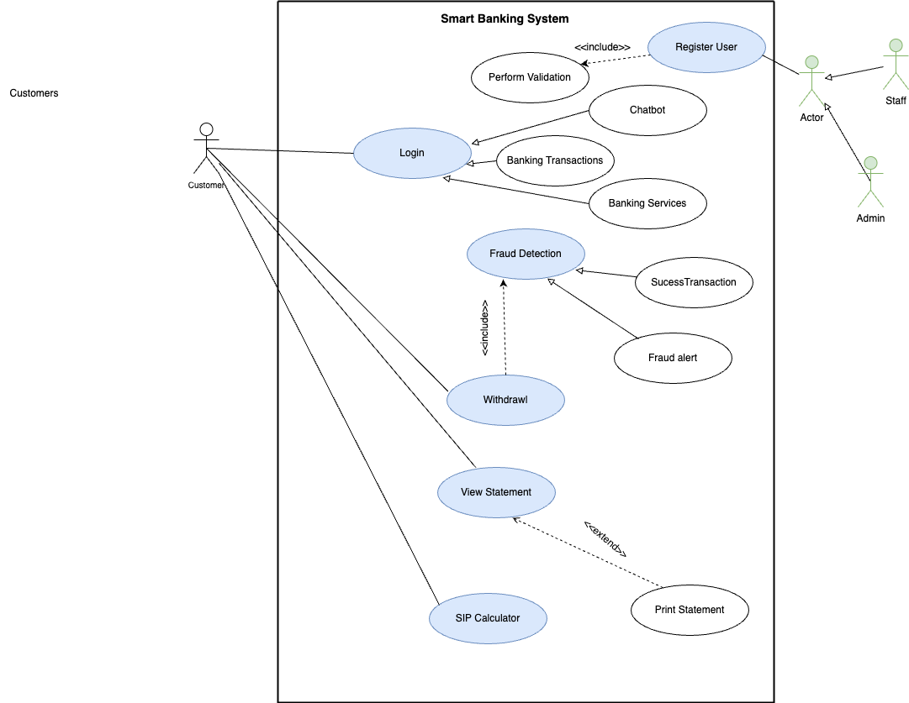

Figure 9 Use Case Diagram

## 3. System Flow Chart

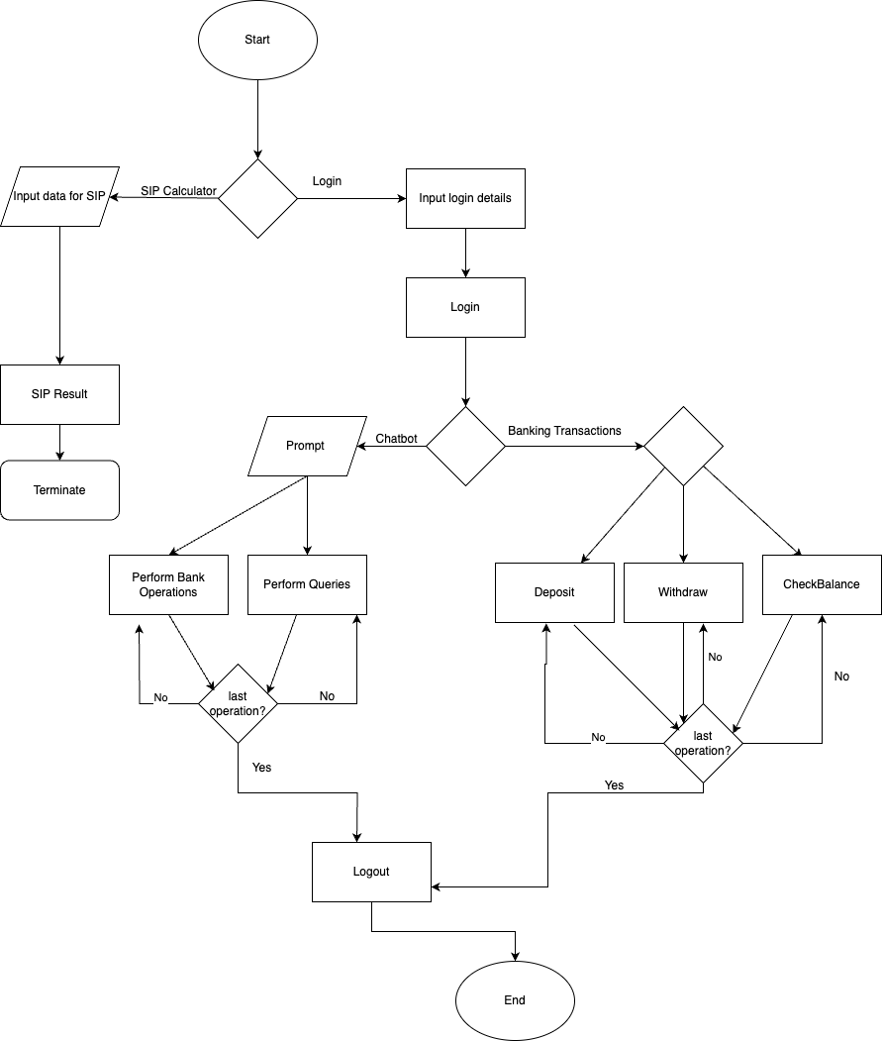

Figure 10 Flowchart of the system

## Future Development Plan:

The future vision for the Smart Banking System is to evolve into a **unified platform** where users can connect and manage multiple bank accounts seamlessly. This enhancement will enable users to track expenses across various banks on a single interface, offering an integrated view of their financial activities. By incorporating an advanced **expense tracking mechanism**, the system will categorize expenditures, generate insightful summaries, and provide real-time alerts for unusual spending patterns. Users will benefit from a consolidated dashboard that summarizes their overall financial health, helping them set budgets and achieve financial goals effectively. Furthermore, the system will **facilitate interbank transactions**, allowing users to transfer funds between accounts from different banks directly within the application. These future capabilities aim to transform the platform into a comprehensive financial management tool, enhancing user convenience and decision-making.

## Targeted Audiences:

1. Customers as Targeted Users

The Smart Banking System is designed to provide customers with a user-friendly and personalized banking experience. With features such as instant query and fraud detection alerts, customers can access banking services conveniently from anywhere at any time. By automating banking processes like fund transfers and account inquiries, the system reduces waiting times and helps to achieve customer satisfaction. This focus on accessibility, security, and customization ensures that the system meets the evolving demands of modern banking customers.

1. Banking Staff as Targeted Users

For banking staff, the Smart Banking System streamlines operations by automating repetitive tasks requiring significant time, like answering frequently asked questions (FAQs) and processing banking operations. This allows staff to make time for more complex issues that require skilled expertise, such as customer relationship management and strategic decision-making. The system’s fraud detection and compliance features provide staff with real-time alerts and tools to address suspicious activities effectively, ensuring a more secure banking environment. By enhancing efficiency and reducing workload, the system acts as a reliable assistant, supporting banking staff in delivering high-quality service to customers.

## Considered Methodology:

1. **Kanban Methodology:**

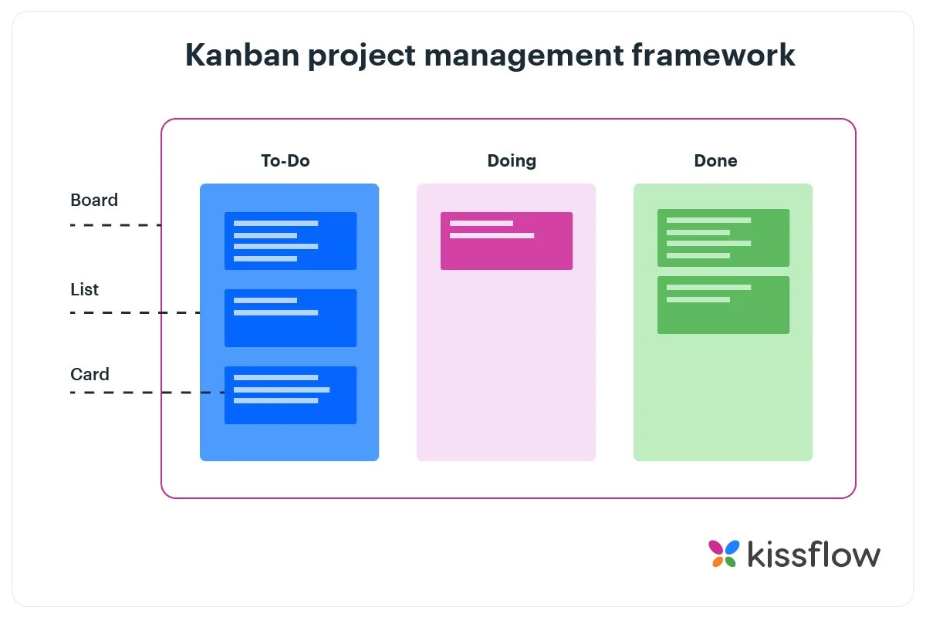It is an agile method which revolves around a kanban board. Kanban Methodology visualizes the entire project to track the flow of the project through its graphical approach. (KissFlow, 2023). It allows external member of the project to understand what is going on the project right now, the completed task and the future task and form a basic understanding. The Kanban board includes following topic:

Figure 11 KanBan Board

1. To-do list
2. Doing
3. Done
4. **Prototype**

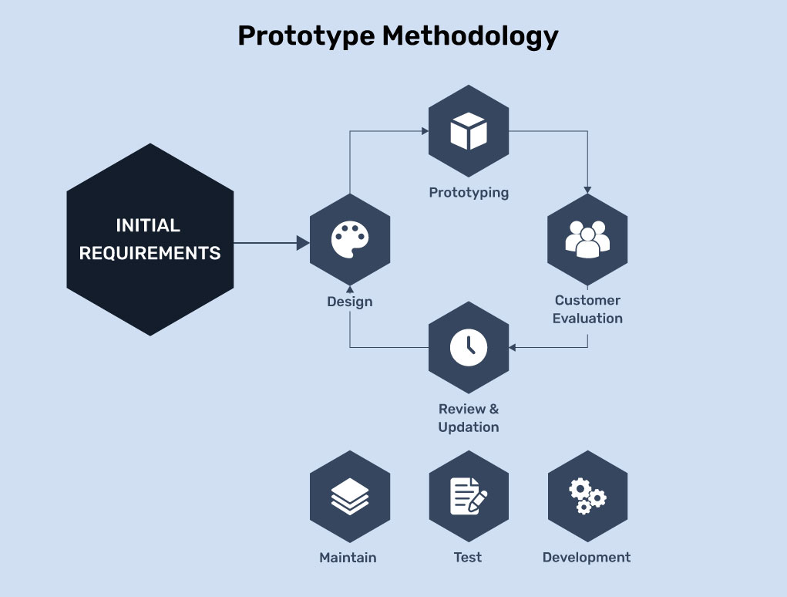Prototype development Methodology is a software development approach that focuses on prototype development and finalizing a product according to the specification of customers. This methodology is particularly useful in scenarios where requirements are not well-defined or are likely to evolve.

Figure 12 Prototype Methodology

(Parag, 2024)

1. **Spiral Methodology**

Spiral Methodology is a software development method which borrows the control and systematic approach of the water fall methodology. (Yuriy, 2019) It focuses on risk management and facilitates incremental releases of a product. This model is particularly suitable for large, complex projects. Key features of the spiral methodology are Iterative development, risk management and prototyping.

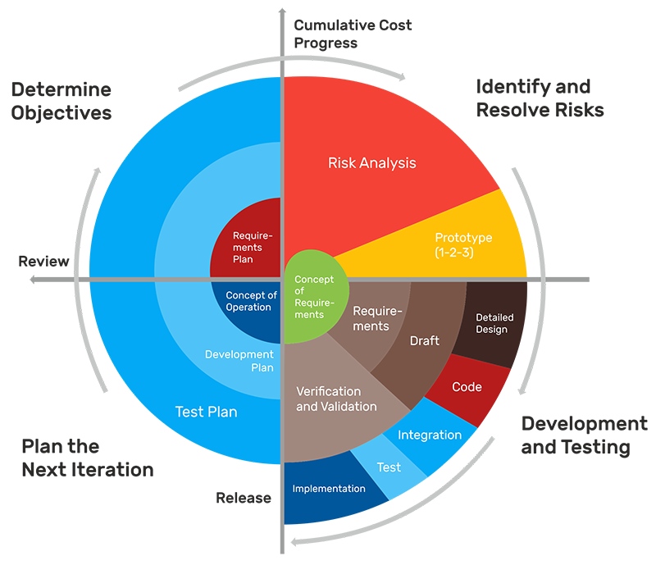

Figure 13 Spiral Methodology

**7. Other methodology:**

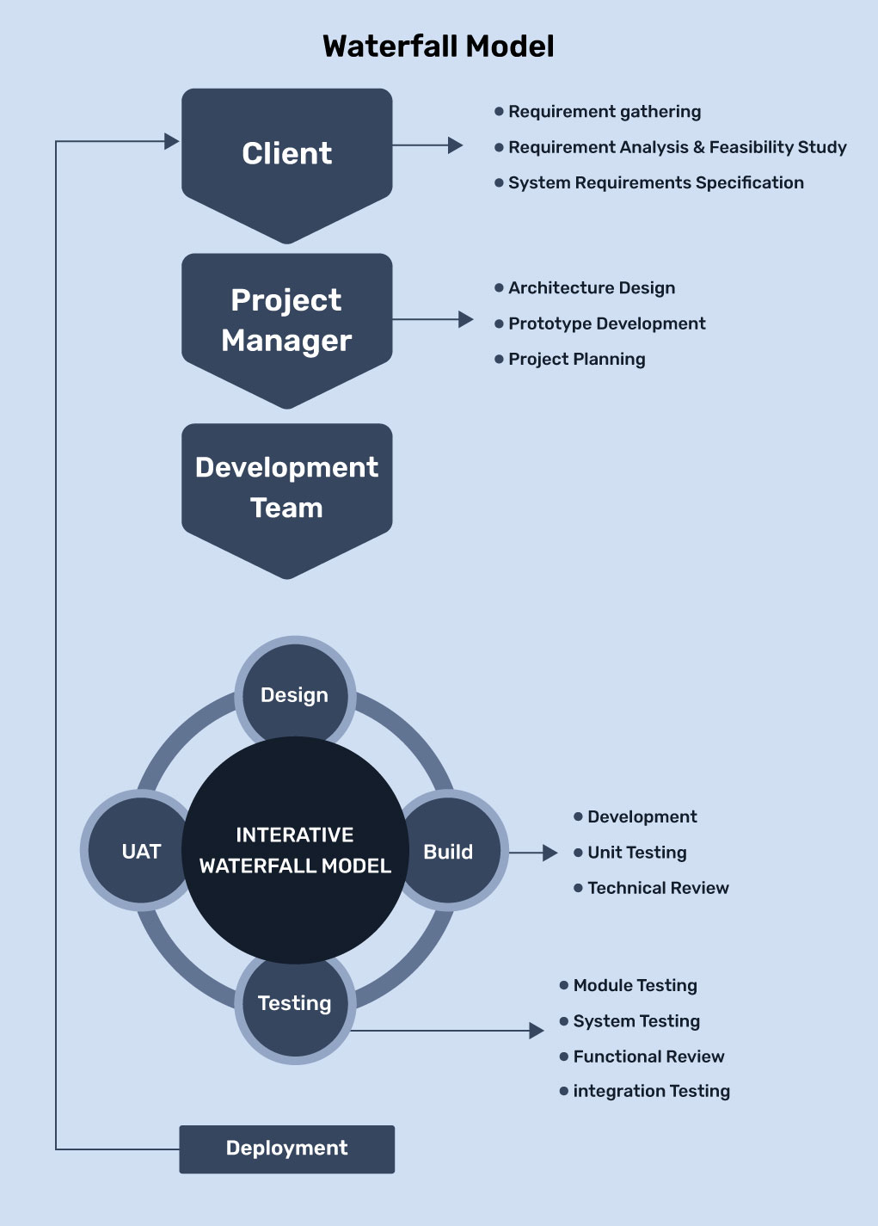a. Waterfall Model

Figure 14 Waterfall Methodology

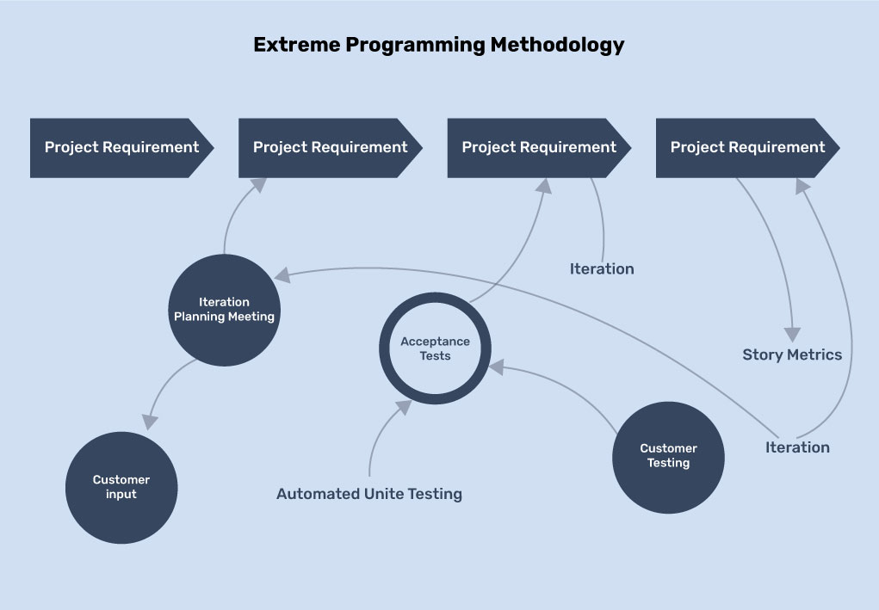b. Extreme Programming (XP):

Figure 15 Extreme Programming Methodology

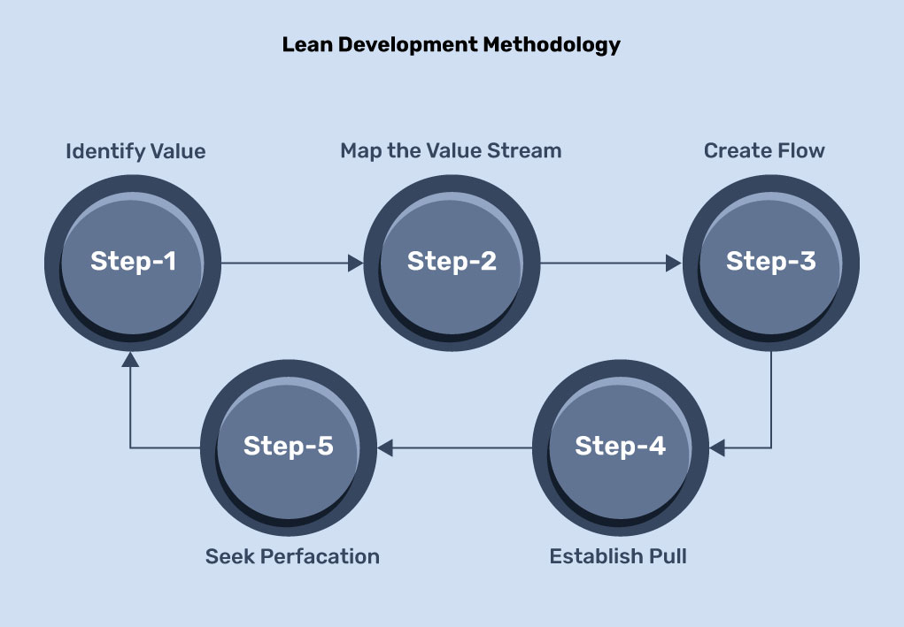c. Lean Development Methodology

Figure 16 Lean Development Methodology

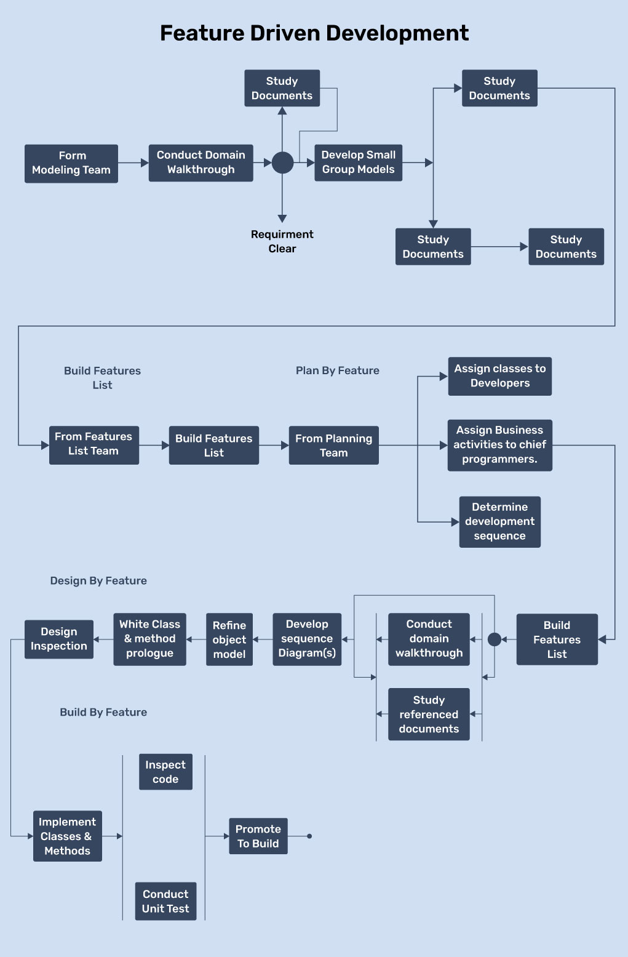d. Feature Driven Development

Figure 17 Feature Driven Development